**Yellow Belt Test Questions & Answers:**

1. Sigma refers to a roman letter that mathematicians use when discussing "average" or "mean"

[ ] True [**X**] False

2. A process operating at 6 Sigma will only generate 3.4 defects per million opportunities?

[**X**] True [ ] False

3. In order to achieve Six Sigma, practitioners follow a standard & rigorous methodology known as **DMAIC**

4. Six Sigma originated in the 1980's at Motorola?

[**X**] True [ ] False

5. To achieve Six Sigma the DMAIC methodology follows which approach

[ ] Brainstorm possible factors then randomly analyze them to find the significant ones

[ ] Use SME knowledge & experience to quickly find solutions

[**X**] Use the transfer function Y=f(x)

6. A Six Sigma process will only produce this many defects per million opportunities **3.4**

7. Achieving Six Sigma has nothing to do with meeting customer expectations?

[ ] True [**X**] False

8. Who is credited as being the father of Six Sigma?

[ ] Bob Galvin [ ] Mikel Harry

[ ] Jack Welch [**X**] Bill Smith

9. Hard costs and soft costs are two types of COPQ

[**X**] True [ ] False

10. COPQ is an acronym that stands for what? **Cost of Poor Quality**

11. Which of the following is the one that is not part of the 7 deadly Muda?

[ ] Defects [ ] Over Production

[ ] Inventory [ ] Waiting

[ ] Movement [ ] Conveyance

[ ] Over Processing [**X**] Measuring

12. The Pareto Principle is named after an Italian economist Vilfredo Pareto

[**X**] True [ ] False

13. CTQ's are translated from VOC

[**X**] True [ ] False

14. CTQ is an acronym that stands for what? **Critical to Quality**

15. DPU is calculated by dividing the number of defects by the number of units

[**X**] True [ ] False

16. In Six Sigma Primary and Secondary Metrics are Mandatory

[**X**] True [ ] False

17. RTY is an acronym that stands for what? **Rolled Throughput Yield**

18. DPU is an acronym that stands for what? **Defects per Unit**

19. DMPO is an acronym that stands for what? **Defects per Million Opportunities**

20. Which of these is not one of the 4 stages of team development?

[ ] Performing [ ] Storming

[ ] Norming [ ] Forming

[**X**] Adorning

21. Which is not a characteristic of a successful team?

[ ] Common goals and working together to achieve that goal

[ ] Team member diversity (skills, knowledge, experience etc.)

[ ] Appropriate resources are available

[ ] Mutual respect

[ ] A good leader exists among the team

[**X**] Complacency exists

22. The **Primary** metric is your critical measure, it's the reason for your project, it's your beacon. This metric is the single most important thing to understand in order for you to be successful.

23. A well written problem statement contains all of the following except

[ ] Baseline [ ] Goal

[ ] Gap [ ] COPQ

[ ] Timeline Reference [**X**] Project Plan

24. From the following, select those that are characteristics of a Lean Enterprise

[**X**] Pull Systems [**X**] Flow

[**X**] Zero Waste [**X**] Availability

[**X**] Flexibility [**X**] Value Add

25. Put these 5S's into the proper order of execution

[ **2** ] Set in Order [ **1** ] Sort

[ **3** ] Shine [ **5** ] Sustain

[ **4** ] Standardize

26. Lean and Six Sigma are Both focused on Quality & Value for the customer?

[**X**] True [ ] False

27. What is the Japanese word for waste? **Muda**

28. What type of muda is waste from working more than required, scheduling more capacity than necessary or using resources that are overkill?

[ ] Inventory [ ] Over-Production

[ ] Motion [ ] Waiting

[ ] Transportation [**X**] Over-Processing

29. **Defects** are flaws, errors or other non-conformities that compromise the value of a product

30. Lean is only about removing waste from the enterprise?

[ ] True [**X**] False

31. The 5 Principals of Lean are paraphrased below, select the correct 5

[**X**] Customer Defines Value [**X**] Identify the Value Stream

[**X**] Continuous Flow [**X**] Pull Where Possible

[**X**] Manage Toward Perfection [ ] Batch Processing

[ ] Work Faster

32. **Over Production** is when more products are produced than are required by the next function or customer.

33. What is this?

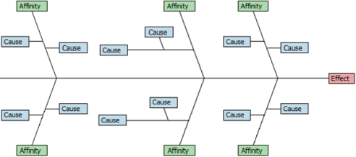

[ ] FMEA [**X**] C&E Diagram

[ ] Process Map [ ] XY Diagram

34. Arrange these C&E process steps into the correct order of execution.

[**3**] Affinitize or group the causes

[**2**] Brainstorm all potentials causes

[**4**] Evaluate

[**1**] Identify & define the effect

35. SIPOC is an acronym using which words?

[**X**] Suppliers [ ] Immediate

[**X**] Inputs [**X**] Process

[**X**] Outputs [**X**] Customers

[ ] Primary [ ] Secondary

36. A SIPOC is another name for a flow chart

[ ] True [**X**] False

37. An FMEA ranks potential failures using values assigned to severity, occurrence and detection?

[**X**] True [ ] False

38. Which of these tools might you use if you want to develop a Risk Priority Number and ranking for the various types of failures that could occur?

[ ] Cause & Effect Diagram [ ] SIPOC

[ ] Functional Process Map [ ] Thought Process Map

[ ] XY Diagram [**X**] FMEA

39. **SIPOC** should be used when trying to understand the links between customers, process steps and process outputs.

40. **Cause & Effect Diagram** should be used when brainstorming possible causes to an effect.

41. What is this?

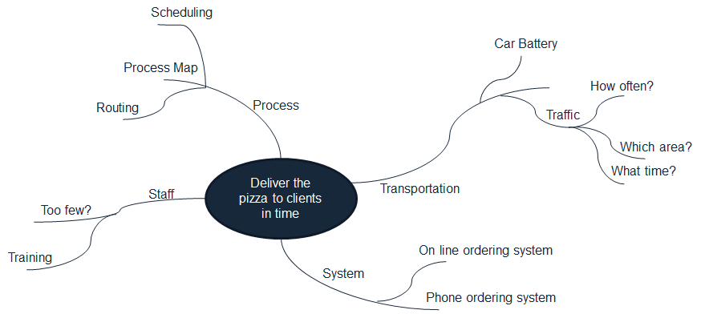

[ ] FMEA [ ] C&E Diagram

[ ] Process Map [ ] SIPOC

[**X**] Thought Process Map [ ] Spaghetti Map

42. Continuous variables are measured, Discrete variables are counted

[**X**] True [ ] False

43. Nominal Data are discrete and rank ordered.

[ ] True [**X**] False

44. Median is the average of a set of data

[ ] True [**X**] False

45. Median is the middle value in a set of data

[**X**] True [ ] False

46. Mode is the value in a data set that occurs most frequently

[**X**] True [ ] False

47. Standard Deviation is a measure that describes how far the data points spread away from the mean

[**X**] True [ ] False

48. For the normal distribution, about **68%** of the data fall within +/- 1 standard deviation

49. For the normal distribution, about **95%** of the data fall within +/- 2 standard deviation from the mean?

50. A **Histogram** is a graphical tool to present the distribution of the data

51. The null hypothesis for a normality test is that the data are normally distributed?

[**X**] True [ ] False

52. Select only those that are examples of graphical analysis tools

[**X**] Box Plots [**X**] Histograms

[**X**] Scatter Plots [**X**] Run Charts

[ ] ANOVA table [ ] Regression Equation

53. Measurement Systems Analysis is a step in a Six Sigma project that ensures the data are reliable and trustworthy before making any data-based decisions.

[**X**] True [ ] False

54. Repeatability evaluates whether the same appraiser can obtain the same value multiple times when measuring the same object using the same equipment under the same environment.

[**X**] True [ ] False

55. Which are common sources of variation in most measurement systems?

[**X**] Part to part variation [**X**] Measurement instrument

[**X**] Repeatability [**X**] Reproducibility

[ ] Humidity [ ] Altitude

56. In a Measurement Systems Analysis, which source of variation do we hope to see be the greatest?

[**X**] Part to part variation [ ] Measurement instrument

[ ] Measurer (person measuring) [ ] Altitude

[ ] Humidity

57. **Bias** is the difference between the observed value and the true value of a measurement.

58. **Reproducibility** evaluates whether different appraisers can obtain the same value when measuring the same object independently.

59. In a Variable Gage R&R, the acceptable % contribution of variation attributable to Repeatability and Reproducibility should be less than **10%**

60. If Kappa is greater than 0.7 the measurement system is acceptable

[**X**] True [ ] False

61. Cp considers the within-subgroup standard deviation and Pp considers the total standard deviation from the sample data.

[**X**] True [ ] False

62. Being stable does not guarantee a process to be capable. However, being stable is a prerequisite to determine whether a process is capable.

[**X**] True [ ] False

63. Cpk measures the process's potential capability to meet the two-sided specifications. It doesn't take the process average into consideration.

[ ] True [**X**] False

64. Cp, and Pp take both the variation and the average of the process into consideration when measuring the process capability.

[ ] True [**X**] False

65. A Pp of greater than 1 suggests...

[ ] Total process variation is greater than the width between the USL and LSL

[**X**] Total process variation is less than the width between the USL and LSL

66. A Pp of less than 1 suggests...

[**X**] Total process variation is greater than the width between the USL and LSL

[ ] Total process variation is less than the width between the USL and LSL

67. Which of the following measurements is NOT a process capability index?

[ ] Cp [ ] Cpk

[**X**] Kappa [ ] Percent Defectives

68. 5S is systematic method to organize, order, clean, and standardize a workplace…and keep it that way?

[**X**] True [ ] False

69. Kanban system is a demand driven system

[**X**] True [ ] False

70. An example of a detective type of Poka Yoke is when your car makes an audible "ding" or alarm when your passenger has not buckled their seat belt?

[**X**] True [ ] False

71. An example of a preventive type of Poka Yoke is when your dishwasher will not start without the door closed?

[**X**] True [ ] False

72. The term "poka-yoke" in Japanese means "signboard"

[ ] True [**X**] False

73. A **Kanban** system is a "pull" production scheduling system to determine when to produce, what to produce and how much to produce based on the demand

74. This word in Japanese means "signboard" **Kanban**

75. Which if these is not a benefit of a Kanban system

[ ] Minimizes in-process inventory

[ ] Prevents overproduction

[ ] Improves responsiveness to dynamic demand

[**X**] Increases dependency on accurate demand forecasts

[ ] Streamlines the production flow

[ ] Visualizes the work flow

76. From the following, select those that are characteristics of a Lean Enterprise

[**X**] Pull Systems [**X**] Flow

[**X**] Zero Waste [**X**] Value Add

[ ] High Levels of Inventory [ ] Several Quality Control Teams

77. Return on investment is the ratio of net financial benefits (either gain or loss) on a project or investment to its financial costs

[**X**] True [ ] False

78. Net present value is the total present value of cash flows calculated using a discount rate?

[**X**] True [ ] False

79. **Control Plans** ensure that the changes introduced by a Six Sigma project are sustained over time

80. **Standard Operating Procedures** are documents that focus on process steps, activities and specific tasks required to complete an operation.

81. Which of these might not be considered a standard element of a control plan?

[ ] SOP (Standard Operating Procedures) [ ] Communication Plan

[ ] Training Plan [ ] Audit Plan

[**X**] Floor plan

82. Control plans typically include measurement systems that monitor and help manage key process performance?

[**X**] True [ ] False

83. Communication Plans are documents that focus on planning and preparing for the dissemination of information?

[**X**] True [ ] False

84 A response plan should be a component of as few control plan elements as possible

[ ] True [**X**] False

85. Which of the following might be used to ensure actions, processes, procedures and other tasks are performed as expected?

[**X**] Audit [**X**] Training

[**X**] SOP's [**X**] Communication

[**X**] Measurements [**X**] Poka-Yoke